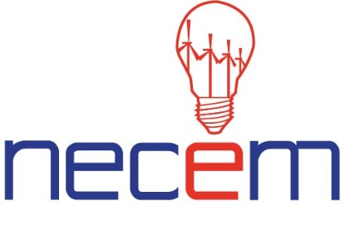

NECEM Summer School: NMR and EPR Spectroscopy for Energy Materials

Newcastle University

Old Library Building, Level 2 (1st Floor)

2nd-4th September 2019
Delegate Information
We look forward to welcoming you to the second North East Centre for Energy Materials (NECEM) Summer School on NMR and EPR Spectroscopy for Energy Materials.
Summer School Schedule and location
The Summer School will run from midday on Monday 2nd September 2019 to 16:00 on Wednesday 4th September on Level 2 (1st Floor) of the Old Library Building (building number 25/26 on attached campus map). Please see the attached schedule.
Registration
Registration will open at 12:00 on Monday 2nd September in the Old Library Building, Level 2 (1st floor) (building number 25 on the attached campus map).

Internet Access

Please see attached information on logging on to the internet whilst on campus.
Refreshments
Buffet lunches, tea and coffee are available throughout the week in the Old Library building, in the foyer outside the lecture theatre 2.21. Drinks and buffet dinner will be served in Old Library Building, Courtyard Private Dining Area on Monday 2nd September (building number 25 on the attached campus map).
Refreshments
Refreshments
Buffet lunches, tea and coffee are available throughout the week in the Old Library building, in the foyer outside the lecture theatre 2.21. Drinks and buffet dinner will be served in Old Library Building, Courtyard Private Dining Area on Monday 2nd and Tuesday 3rd September (building number 25 on the attached campus map).
Delegate Accommodation
If you requested accommodation when you registered the hotel details are as follows: The Caledonian Hotel is located in Jesmond, just one mile away from the Newcastle University City Centre campus.
The Caledonian Hotel
Osborne Road
Jesmond
Newcastle upon Tyne
NE2 2AT
Tel: 0191 281 7881

Social Media

Please follow NECEM on Twitter @NECEM_NE
Please be sure to tag us in your photos and mentions throughout the event.

Key Contact

Justina Heslop
NECEM Project Support Co-ordinator
Email: Justina.Heslop@newcastle.ac.uk
Phone: 0044 (0)191 2087287
Poster Presentation Call for Abstracts
We invite all delegates to submit an abstract for a poster presentation during the Summer School. The deadline for submitting your abstract is August 23rd 2019. Please email your abstract to Justina.Heslop@newcastle.ac.uk and indicate if you would like to present a two minute verbal presentation of your poster.
Please see the guidelines below:

Abstract title
F. Author¹ and S. Author²
¹Institute, Town, Country
² Another Institute, another town, another country
E-mail: name@mymail.cy Year of PhD study: 1st/2nd/3rd/4th year (delete as appropriate)
The abstract should be headed by a title, author name(s) and complete address(es) of the author(s). Please underline the name of the author who will give the presentation. The abstract should not exceed 300 words (excluding references) and can contain a single figure with the caption formatted as below.

Figure 1: [description of figure].

